Green Meadow
Back-To-School Social!

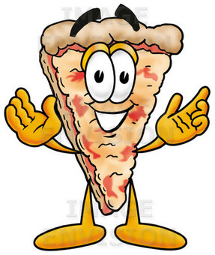

Friday, September 13th
5:30pm - 7:00pm
Green Meadow Cafeteria

Come join us for our back-to-school social!
Have dinner and meet friends on the playground!

Cheese pizza and water are free!
Desserts* and flavored drinks will be available for purchase.

*To contribute a dessert, please bring it to school on Friday, 9/13.

Sponsored by the Green Meadow PTO!

